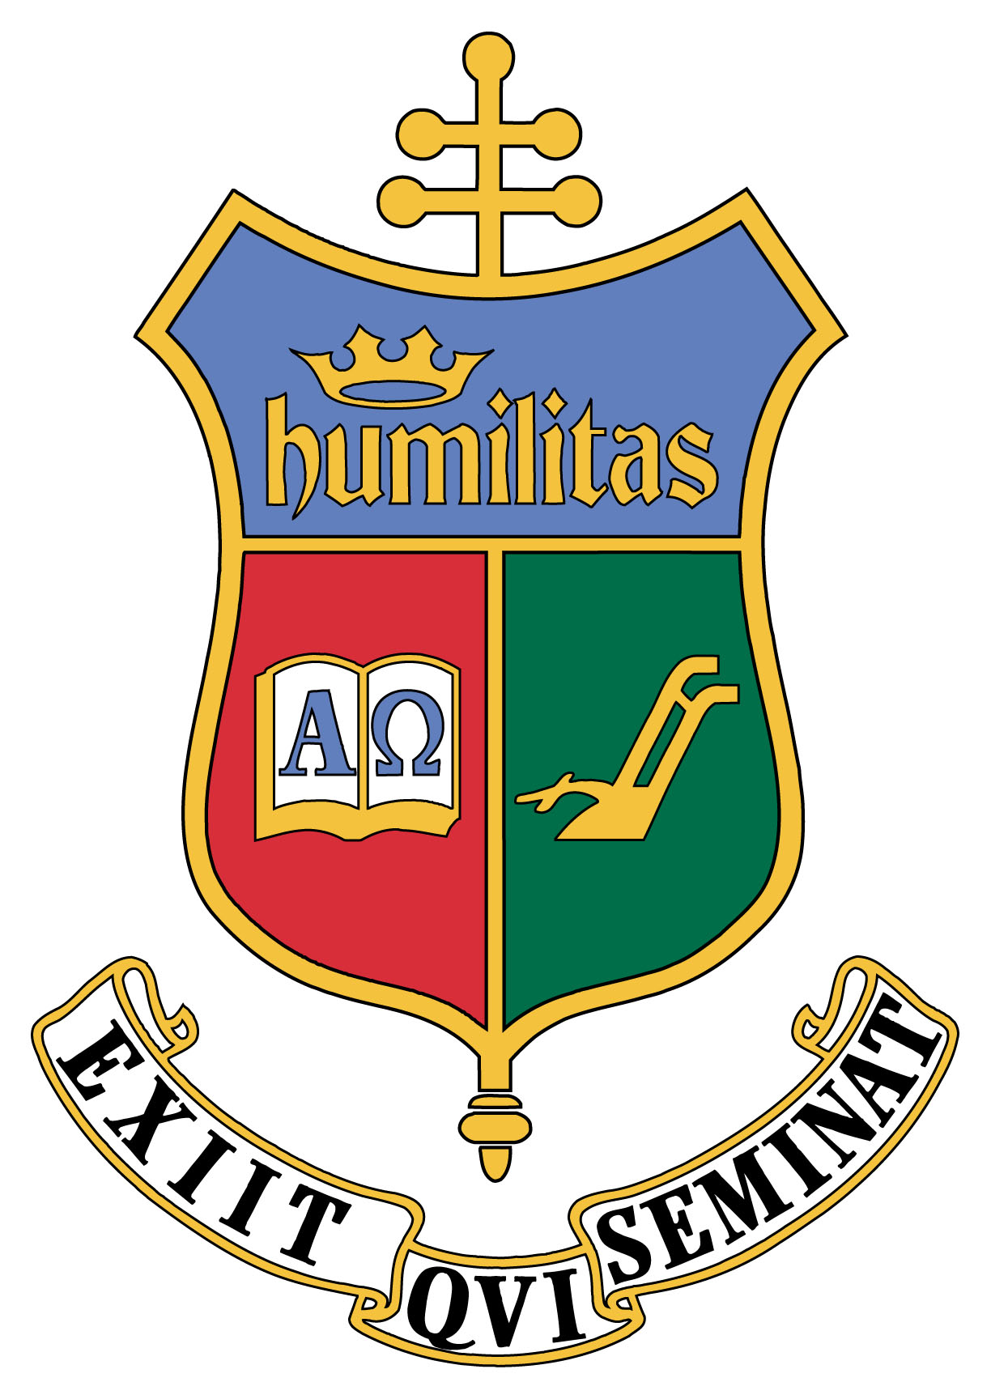
School of Diaconal Formation

Saint Charles Borromeo Seminary
1400 Evans Road | Ambler, PA 19002
610-785-6244 | diaconate@scs.edu

Pastor’s Evaluation for Ministry of Lector

If handwriting or printing responses, please use a separate piece of paper if more space is needed to avoid double-sided pages. Thank you!

Name of Candidate:

Parish:

I. Please list the areas of ministry in which your candidate has been involved during his formation up to this time.

II. How has he performed in these areas? (Your response should include but not be limited to: fidelity to tasks assigned; punctuality; competency; ability to work with those in authority; ability to work with others?)

III. Since your candidate is petitioning for the Ministry of Lector, comment specifically on his ability to proclaim the Word of God; his public speaking; any gifts or deficiencies in the area of catechetics; knowledge of the faith; ability to explain the faith; any other comments which would be associated with this ministry.

IV. Do you perceive any particular ministerial competency or gifts which mark this candidate’s pastoral activity? Please describe.

V. Do you perceive any significant formation deficiency which needs to be addressed during the rest of this candidate’s formation? Please describe.

VI. Overall Evaluation

How would you assess his strengths and areas for growth?

Strengths:

a.

b.

c.

Areas for Growth:

a.

b.

c.

VII. Recommendation for the Ministry of Lector

Do you recommend that he be installed as a Lector?

Without reservation

My reservation is

I do not recommend at this time because

Signature

Date

PARISH SEAL (seal is not required if returned electronically)

